Java Shift Operators
There are three types of shift operators in Java:
- Left Shift (<<)
- Right Shift (>>)
- Unsigned Right Shift (>>>)
Left Shift Operator:

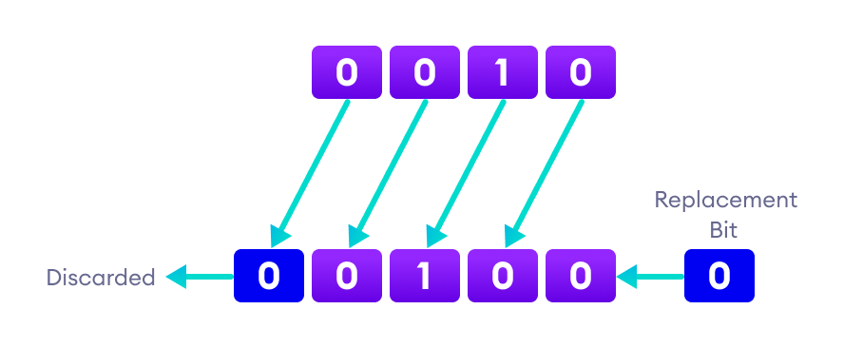

0 0 1 0

0 1 0 0

Right Shift Operator:
// right shift of 8
8 = 1000 (In Binary)

// perform 2 bit right shift
8 >> 2:
1000 >> 2 = 0010 (equivalent to 2)

